Dialogue Scripting Tool

Sprint 3: First Implementation

Team 6

Shutong Ji
Swarna Sweth
Aryan Navin
Leyan Huang
Jay Stadelman

Software Engineering I
CS-GY 6063 - I2
Fall 2026

Instructor: Raz Saremi
Date: 2026.11.03

Repository Link: Dialogue Scripting Tool

AI-Use Disclosure:
AI was used in the process of making this document.
- ChatGPT-6
  - Used for research into markdown to reactflow GUI
  - Assistance in US-1 creation
    - Troubleshooting parser regex expressions
    - Assistance with initializing Django server
    - Assistance with SQLite db setup for local demos and testing
    - Readme reviewed by AI
- Claude Sonnet 5.5
  - Generated git commit message and pull request template in us-37 branch
  - Assisted in US-31 creation
- Gemini 3.6
  - Used for research on the node graph GUI.

Sprint backlog
Sprint goal: The goals for this sprint are:
- Set up the system to parse text on a markdown file into a node GUI (bidirectional)
- Set up the database system to host GUI information and user credentials
- Have independent demos for both systems

ID | Story | Acceptance Criteria | Owner | Estimate (Hours) | Status | PRs / Commits | Reviewer
US-12 | Create a node and mark it as the start of a conversation | No change  Link to US-12 | Swarna | 5 hours | In progress | Branch  PR #8 | Shutong
US-31a | Teams and membership checks for project access | Changed, see below | Aryan | 10 hours | Completed | PR #3 | Leyan
US-01 | End-to-end visualization of the project, from Markdown to nodes to JSON | Yes change  Link to US-1  This US no longer has JSON output requirements or AC | Primary: Jay  Secondary: Shutong | 10 hours | Completed | PR #4 | Swarna
US-29 | Visualizing the connections for choices and jump commands | AC1 has changed the requirement.  link to US-29 | Shutong | 10 hours | Completed | PR #6 | Jay
US-37a | Saving a project to the cloud and reopening it | Changed, see below | Leyan | 12 hours | Completed | PR #2, PR #5 | Aryan

Product backlog

Stories not chosen for this sprint

MVP
- US-35 (Merged US-11, US-28): Bidirectional manual sync. Pushing node edits back to Markdown and updating nodes from Markdown.
- US-32 (Modified US-10): Setting conditional dialogue logic through player choices and jump commands
- US-36 (US-14): Deleting unwanted nodes and branches, including multiple selections, and undoing changes
- US-20: Undoing changes through a button or keyboard shortcut
- US-13: Node comments
- US-02: Checking that node connections are valid
- US-34 (Merged US-06, US-07): Exporting variable definitions and player-choice effects with the JSON file
- US-17: Including a version number and validating the JSON before export
- US-25: Exporting dialogue project data into a JSON AST file

Stretch
- US-24: Line hashes
- US-03: Translation catalog
- US-15: Speaker validation
- US-33 (Merged US-04, US-16): Groups + metadata
- US-21: Search
- US-19: Node colors
- US-08: Playtest
- US-09: Variable inspector

Story added, split, merged, or dropped
Stories changed since Sprint 1:
- US-37 was split into US-37a and US-37b. Cloud save and reopen was built this sprint, and the editor part depends on the US-01 editor, so it moves to the next sprint.
Why these changed: US-37 was split. The parser rebuilds nodes and connections from the saved Markdown (design 3.1.1), so this story covers storing the Markdown and positions. Showing them in the editor moves to US-37b.
  - US-37a: Saving a project to the cloud and reopening it - Leyan
As a Narrative Designer, I want my project's dialogue and node positions saved to the cloud and restored when I reopen it, so that I can continue my work later or on another machine.
- Given a team member, when they create a project, then it starts empty at revision 1.
- Given saved dialogue and node positions, when the project is reopened, including after a server restart, then the same Markdown and positions are returned, and the Markdown is stored as a commit in a private GitHub repository.
- Given an outdated copy of the project, when it is saved, then the save is rejected with 409 and the saved project is unchanged.
- Given a user who is not signed in or not on the project's team, when they create, open, or save a project, then the request is rejected with 401 or 403.
  - US-37b: Creating, opening, and closing projects in the editor. Estimate: 8 hours.
As a Narrative Designer, I want to create, open, and close projects in the editor, so that I can start new work and continue existing work without losing changes.
- Given the Narrative Designer is using the tool
When they create a new project
Then the editor opens a new empty project workspace.
- Given a project saved in the cloud
When they open it
Then the editor restores its dialogue, nodes, connections, and positions.
- Given unsaved changes, including moved nodes
When they close the browser tab
Then the tool prompts them to save or discard the changes.
- US-01 was amended to not have a JSON export component due to this task being US-25.
- US-31 was split into US-31a and US-31b. The team and membership data, and the check that decides who belongs to a team, were built this sprint. The login endpoint and the pages that use it depend on work that is not finished, so this has moved to the next sprint.
  - US-31a (Split from US-31): Teams and membership checks for project access - Aryan
As a Narrative Designer, I want my team membership to be recorded and checked, so that only members of a team can be treated as having access to that team’s projects.
    - 1. Given a staff user in the admin, when they create a team and add a user to it, then the team and the membership are saved and can be read back.
2. Given a user who is a member of a team, when the system checks their membership, then the check returns true.
3. Given a user who is not a member of the team, or a user who is not signed in, when the system checks membership, then the check returns false.
4. Given a user who is already a member of a team, when the same membership is added again, then it is rejected, so a user can belong to a team only once
  - Why these changed: US-31 covers login, access, and the outdated-save check. Membership is the part finished this sprint (PR #3, with 4 automated tests). The outdated-save rejection (409) and the 401 or 403 responses for projects are covered by US-37a, so they are not repeated here.
  - US-31b (Split from US-31): User login and teams dashboard - Aryan
Estimate: 10 hours
As a Narrative Designer, I want to sign in with my email and password and see my team’s projects, so that I can securely store, retrieve and update my narrative scripts across browser sessions.
Acceptance Criteria:
    - 1. Given a registered user who is signed out, when the sign in with a valid email and password, then the systems signs them in, returns a sign-in token, and shows their teams dashboard.
2. Given a user who enters a wrong password or an email that is not registered, when they try to sign in, then the request is rejected with 401 and no token is returned.
3. Given a request to sign in with the email or the password missing, when it is sent, then the request is rejected with 400 and says which field is missing.
4. Given a user who is not signed in, or whose token is invalid or expired, when they request a team project, then the request is rejected with 401 and no project data is returned.

- US-29 specified that only jump commands that break mid-dialogue will be dotted line, because we want the visual difference to distinguish how narrative flows, not how mechanics works.

Deployment and Demo Script
US-1 has a full demo of a markdown to a GUI and a GUI to a markdown parsing. It is not connected to any security or the Neon database, but it can be hosted locally using SQLite. Instructions for running the demo for Mac and Windows are available in the readme.
US-29 is aiming for rendering branches to illustrate the narrative flow in the GUI. It uses the base of US-1, building upon it to read node choices and jump commands and render them as solid or dotted lines.
US-37a has a demo of creating, saving, and reopening a project through the project API. It saves node positions in the Neon database and the Markdown in a private GitHub repository, but it is not connected to the editor yet. Instructions for running the demo for Mac and Windows are available in the readme.
US-31a has a demo of creating a team and adding a user to it in the Django admin, then running the automated tests that show a member is recognized and a non-member, a signed-out user, and a duplicate membership are rejected. It is not connected to a login page yet, because signing in moves to US-31b. Instructions for running the tests are available in the readme.

Design changes
US-01: None, we are removing the JSON export aspect of the user story because US-25 covers this component.
US-29: AC1 has changed to that only jump commands that transit in mid-dialogue will be drawn as a dashed line. The difference between a solid line and a dashed line should indicate whether the transition is due to the natural end of a node or a conditional jump in the middle of a node. Thus, if the jump command is at the end of the node, it should be drawn as a solid line. The branch rendering should provide information about how narrative flows between nodes, whether they cut forcefully or they end naturally, for narrative design. The previous AC1 was more for programmers' convenience, not for narrative designers.
US-37a: None. The API uses Django session login for now because the US-31 JWT login endpoint is not built yet.
US-31a: None.

Daily scrum reports
Date | Members | Time Spent
22nd October 2026
23rd October 2026
24th October 2026 | - Shutong & Jay: research on the visual node graph projection solution. | Shutong: 1 hour  Jay: 1 hour
25th October 2026 | - Leyan: research on connecting Django to the Neon Postgres database, and on the custom user model. | Leyan: 1hours
26th October 2026 | - Aryan: researching on setting up login/password along with database, and basic stuff regarding team projects  - Leyan: researching Django migrations and how US-37 saves and reopens a project with Postgres and GitHub. | Aryan: 4 hours  Leyan: 1 hours
27th October 2026 | - Leyan: connected Django to Neon Postgres and opened draft PR #1 for the backend setup, with the custom User model and README setup steps.  - Shutong: prototype of connecting a JSON file with React Flow.  - Jay: US-1 technology research | Leyan: 2 hours  Jay: 1 hour  Shutong: 2 hours
28th October 2026 | - Jay: US-1 markdown to GUI research and prototype  - Aryan: Read through data design for user/team/teamMembership and checked what Leyan’s backend setup covers, so US-31 can build on it  - Leyan: started the US-37 project API (create, open, save with a revision check) with tests.  - Shutong: Prototype of line styles in React Flow. | Aryan: 2 hours  Leyan: 2 hours  Jay: 2 hours  Shutong: 2 hours
29th October 2026 | - Jay: US-1 prototype iteration | Jay: 2 hours
30th October 2026 | - Swarna: Set up the environment and codebase.  - Aryan: Got the local setup running from Leyan’s README  - Leyan: reopened the backend setup as PR #2 under the team branch format and worked through Aryan's review | Aryan: 3 hours  Leyan: 0.5 hours  Swarna: 0.2 hours
31th October 2026 | - Swarna: Added the starting node functionality to Jay’s code according to US-12  - Aryan: Reviewed and approved Leyan’s backend setup PR | Aryan: 2 hours  Swarna: 0.3 hours
1st Nov 2026 | - Jay: pushed prototype into feature branch  - Leyan: merged the approved backend setup (PR #2) into development  - Shutong: used Jay’s prototype as the parser to connect the US-29 prototype with visualization from React Flow.  - Swarna: Created Branch with starting node functionality | Leyan: 0.5 hours  Jay: 0.5 hours  Swarna: 0.4 hours  Shutong: 1 hour
2nd Nov 2026 | - Aryan: Made the US-31 branch, and built the Team/TeamMembership models, pushed the branch, and opened a PR for Leyan to review  - Jay: Made US-1 PR assigned Swarna as reviewer  - Leyan: reviewed and approved Aryan's US-31 PR #3. Also synced US-37 with US-31, stored project Markdown in a private GitHub repository, and fixed the PR #2 review items.  - Swarna: Created the PR for US-12  - Shutong: Made US-29 PR assigned Jay as reviewer. | Aryan: 5 hours  Leyan: 3 hours  Jay: 1 hour  Swarna: 0.2 hours  Shutong: 1 hour
3rd Nov 2026 | - Jay: Reviewed and Merged US-29 into US-1 branch, updated US-1 PR based on feedback, updated to resolve merge conflicts, updated readME with instructions to run demos and tests  - Swarna: Updated Testcases  - Shutong: Reviewed US-12 PR.  - Leyan: checked that the accounts and teams demo works on Jay's rebased branch, merged development into PR #5 and moved the project API to the Neon settings, fixed Aryan's review comments, added the email migration, updated the README, and merged PR #5 into development.  - Aryan: Reviewed Leyan’s PR #5 and started work on US-37b | Jay: 6 hours  Swarna: 1 hour  Leyan: 2 hours  Shutong: 1 hour  Aryan: 1 hour

For sprint 3 we anticipated we would need 47 hours to complete our user story tasks. We actually took approximately 52.6 hours to complete the stories. This does not include the final edits required on this document.
Total Sprint Velocity = Ideal Time / Elapsed Time = 47 / 52.6 = 0.89

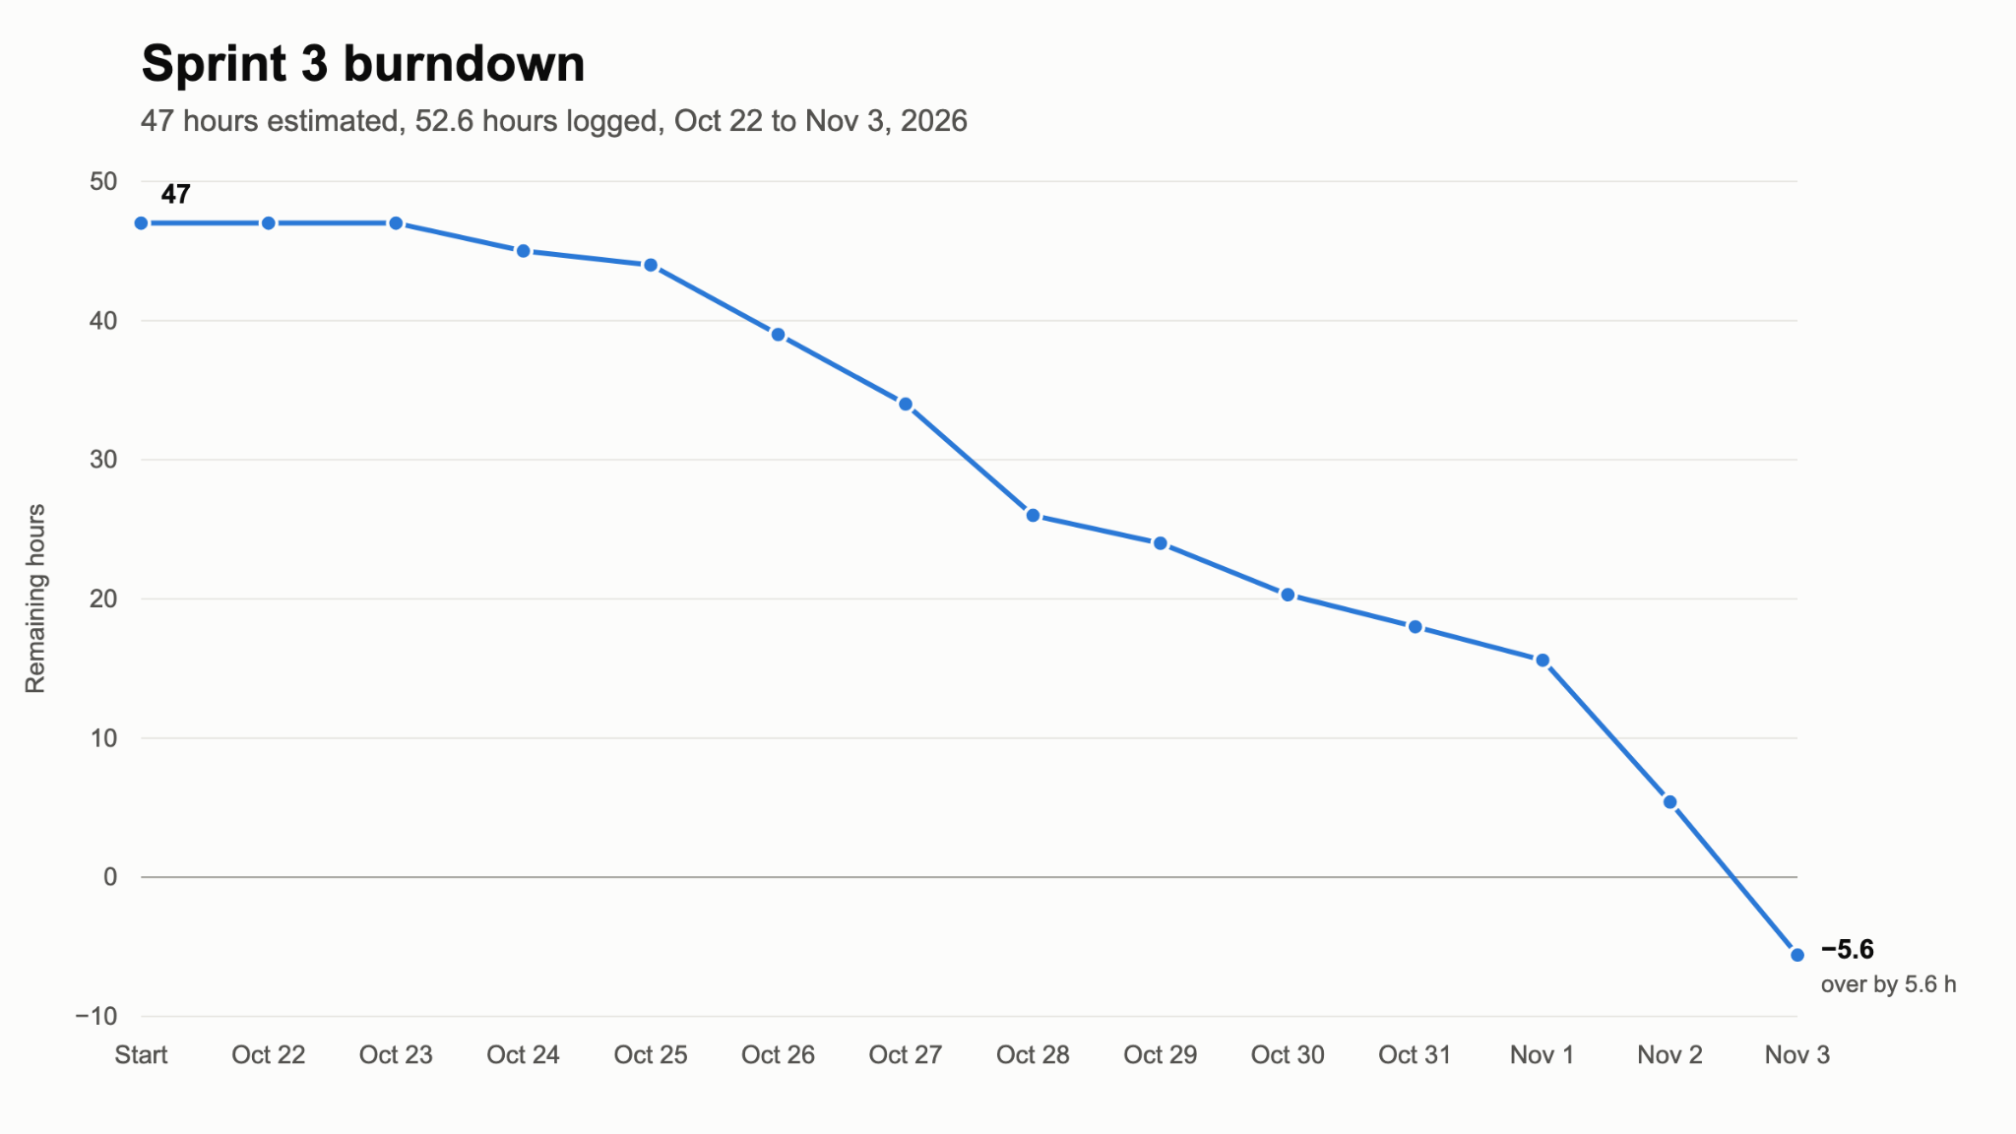

Sprint retrospective report
Sprint retrospective meeting:
Date: 3rd November
Attendees: Shutong Ji, Swarna Sweth, Aryan Navin, Leyan Huang, Jay Stadelman
What went well:
- Team collaboration
  - Everyone attended meeting, responded on slack, and collaborated during PR process
- Node GUI research
  - Able to find a product for the GUI interactions
  - https://reactflow.dev/
- Neon set up
  - Relatively easy set up and testing
- Backend tests are working
What didn’t go well:
- Found some of the stories were too large and complex to complete in a single sprint
  - Had to split some US to move project forward
- Some user stories blocked other user stories causing delays in development
  - Shutong's node connection work needed Jay’s parser work
- Because each piece was developed independently Jay experienced a significant amount of merge conflicts
- Hard to adjust to the coding environment at the beginning of the sprint
  - No one on this team has spent time with Django outside of this class
- Last minute merges caused some stress.
  - Had many merge conflicts and last minute updates.
Planned versus completed work (stories and points):
Planned on completing: US-01, US-12, US-29, US-31, US-37. This was a total of 11 story points and estimated to be 47 hours of work. In retrospect US-01 should have been a 3 point item and US-31 and US-37 were more than a 3 point story. We were able to complete each story, with some modifications. US-31 was split into US-31a and US-31b with US-31a being completed this sprint while US-31b will be considered in the next sprint. US-01 had the JSON export component removed as it is redundant with US-25. US-37 was split into US-37a and US-37b. US-31a is completed this sprint but US-31b will be considered in the next sprint.

Action Items for the Next Sprint | Owner | How to test these
- Complete programming US-31b which consists of the login features for users | Aryan | Run the automated login tests, then sign in on the running server. Check that valid credentials return a token, a wrong password returns a 401, and a requisition with a bad token is rejected.
- Complete US-37b: create, open, and close projects in the editor | Leyan | In the browser, a new project opens an empty workspace, a saved project reopens with its dialogue, nodes, connections, and positions, and closing the tab with unsaved changes prompts to save or discard.
- US-35 - Complete bidirectional syncing between markdown and node GUI | Jay | - Edit the markdown  - Click sync  - Review node GUI for update  - Edit the node GUI  - Click sync  - Review markdown for update
US-36 - Deleting unwanted nodes and branches, including multiple selections, and undoing changes | Jay | Delete  - In the node GUI interface selecting delete on node or branch  - Review that the node/branch is no longer in GUI  - Review markdown to ensure the section is no longer present.  Undo:  - Take an action in GUI (make node, delete, etc)  - Select undo  - Review GUI and markdown to ensure action was undone.
US-02 - Checking that node connections are valid | Swarna | Node with no connections:  The tool should return an error message indicating there is a node without any connectors and what node is causing this error  Connector without any nodes:  The tool should return an error message indicating there is a connector without any nodes and what connector is causing the error.
US-13 - Node comments | Shutong | User can add comments on nodes. Only the user who created the comment can delete the comment. Those comments should not appear on the exported JSON.

Scrum Meetings
Date: 28th October
Agenda: Discuss Sprint Progress and Mid Sprint Review
- Shutong and Jay shared ideas regarding their story. Shutong shared the MIT opensource software called ReactFlow which contains the node visualization logic
- Leyan created a PR which Aryan is yet to review

Date: 30th October
Agenda: Discuss Sprint Progress and Mid Sprint Review
- All members discussed their updates
- Jay demoed his updates
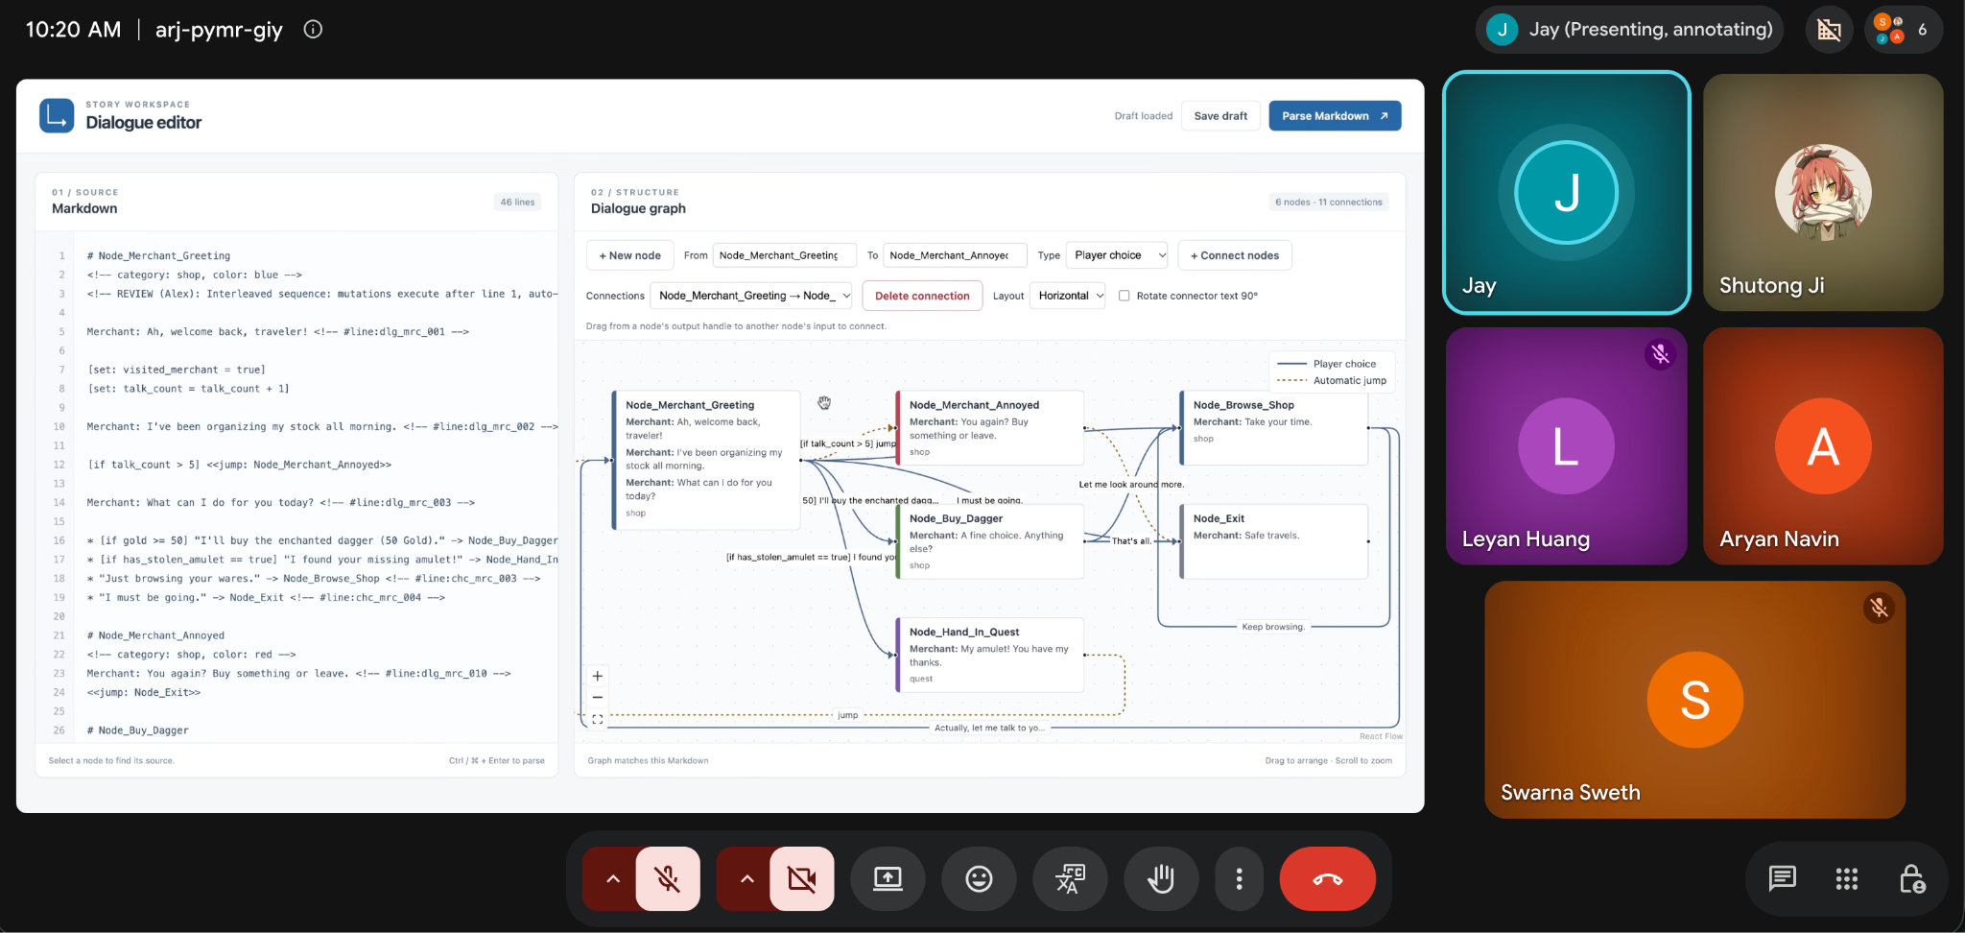

Date: 1st November
Agenda: Discuss Sprint Progress
- All members discussed their updates
- Jay demoed his updates and pushed to his branch
- The team decided that backend and frontend integration is a huge task and will have to be pushed to the next sprint
- US-01 will be split and spilled over into the next sprint
- Everyone has to add their design changes and review PRs tomorrow

Date: 2nd November
Agenda: Discuss Sprint Progress and the Sprint 3 Document
- All members discussed their updates; Swarna demoed the starting node feature and will open a PR after the meeting
- Leyan's US-37 cannot be completed in this sprint, so it will be split
- The team reviewed the Sprint 3 document; Leyan and Jay will add their split stories to the product backlog, and everyone will add their part to the demo script
- Hosting (AWS or localhost) and the demo will be decided tomorrow; Jay will ask the professor whether the demo must run from the main branch
Date: 3rd November
Agenda: Complete First Implementation Document and tabulate the Burnout Chart for the Sprint. Conduct the Retrospective Meeting.
- Aryan and Leyan had a discussion about how to demo the backend
- The team reviewed the demo

